Objectives:

* Authenticate the username and password.

**There is ONE challenge exercise worth 100%.**

**Project #1 (Building the Database and Table).**

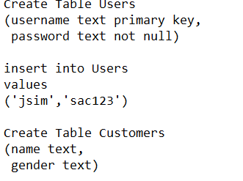

**Project #2 (Building the Login and Customer windows with TKINTER).**

**Challenge Exercise:** On the Customer Window create a second button that will exit the window and show the login window. The user will have the capability to exit and enter the application.

**#1 Print screen the running application below here, multiple print screens are needed.**

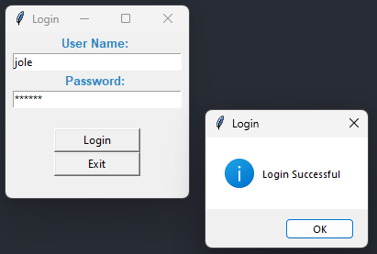

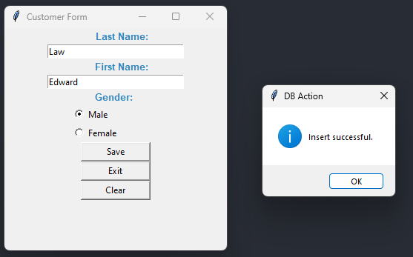

**Copy and paste your code below here.**

Code:

import tkinter as tk

import sqlite3 as sql

from tkinter import messagebox

def login():

username = txtusername.get()

password = txtpassword.get()

#open connection

conn = sql.connect("C:\\Users\\17147\\Desktop\\SQLLite\\PythonClassDB.db")

crs = conn.cursor()

crs.execute("SELECT * FROM login where username=? and password=?", (username, password))

rows = crs.fetchone()

if rows:

messagebox.showinfo(title="Login", message="Login Successful")

show_customer_form()

else:

messagebox.showerror(title="Login Error", message="Invalid username or password.")

txtusername.delete(0, tk.END)

txtpassword.delete(0, tk.END)

txtusername.focus_set()

def show_customer_form():

def save_entry():

last_name = txtln.get()

first_name = txtfn.get()

gender = gender_selected.get()

#open connection

conn = sql.connect("C:\\Users\\17147\\Desktop\\SQLLite\\PythonClassDB.db")

crs = conn.cursor()

crs.execute("INSERT INTO customers (last_name, first_name, gender) VALUES(?,?,?)", (last_name, first_name, gender))

conn.commit() #Commit transaction

conn.close() #Close connection

messagebox.showinfo(title="DB Action", message="Insert successful.")

txtln.delete(0, tk.END)

txtfn.delete(0, tk.END)

rbMale.select()

gender_selected.set("Male")

txtln.focus_set()

def exit_entry():

entry_win.withdraw()

txtusername.delete(0, tk.END)

txtpassword.delete(0, tk.END)

login_win.deiconify()

def clear_entry():

txtln.delete(0, tk.END)

txtfn.delete(0, tk.END)

rbMale.select()

gender_selected.set("Male")

#unload login window

login_win.withdraw()

#create entry form

entry_win = tk.Tk()

entry_win.title("Customer Form")

entry_win.geometry("300x300")

#setup labels, textboxes, and ribbon

lblln = tk.Label(entry_win, text = "Last Name: ", font="Arial 10 bold", width=12, anchor="e", fg="#2E86C1")

lblln.pack()

txtln = tk.Entry(entry_win, width=30)

txtln.pack()

lblfn = tk.Label(entry_win, text = "First Name: ", font="Arial 10 bold", width=12, anchor="e", fg="#2E86C1")

lblfn.pack()

txtfn = tk.Entry(entry_win, width=30)

txtfn.pack()

lblgender = tk.Label(entry_win, text = "Gender: ", font="Arial 10 bold", width=12, fg="#2E86C1")

lblgender.pack()

gender_selected = tk.StringVar(entry_win)

rbMale = tk.Radiobutton(entry_win, text="Male", value="Male", variable=gender_selected)

rbMale.pack(anchor="w", padx=90)

rbFemale = tk.Radiobutton(entry_win, text="Female", value="Female", variable=gender_selected)

rbFemale.pack(anchor="w", padx=90)

gender_selected.set("Male") #setting default to Male

btnsave = tk.Button(entry_win, text="Save", command=save_entry, width=12)

btnsave.pack()

btnexit = tk.Button(entry_win, text="Exit", command=exit_entry, width=12)

btnexit.pack()

btnclear = tk.Button(entry_win, text="Clear", command=clear_entry, width=12)

btnclear.pack()

def quit():

login_win.quit()

login_win.destroy()

#Set up window form

login_win = tk.Tk()

login_win.title('Login')

login_win.geometry("200x180")

# Input

lblusername = tk.Label(login_win, text = "User Name: ", font="Arial 10 bold", width=12, fg="#2E86C1")

lblusername.pack()

txtusername = tk.Entry(login_win, width=30)

txtusername.pack()

lblpassword = tk.Label(login_win, text = "Password: ", font="Arial 10 bold", width=12, fg="#2E86C1")

lblpassword.pack()

txtpassword = tk.Entry(login_win, width=30, show="*", )

txtpassword.pack()

lblspace = tk.Label(login_win, text = " ", font="Arial 10 bold", width=12, fg="#2E86C1")

lblspace.pack()

# Create buttons on windows form

btnlogin = tk.Button(login_win, text="Login", command=login, width=12, )

btnlogin.pack()

btnquit = tk.Button(login_win, text="Exit", command=quit, width=12)

btnquit.pack()

login_win.mainloop()

**Submit this document to Module 5 Class Exercise.**